Rio Rancho Club of New Mexico
“HAPPENINGS” May 23, 2017
Jerry Reeder was out Rotarian of the Day. Jerry provided an excellent presentation by the RRPS Supt. Dr. Sue Cleveland thanked our club for all we do for the students and teachers. She gave an overview and comparison of RRPS to other districts around the state. The RRPS is the largest employer in Rio Rancho. She would like to see more businesses and manufacturers move to Rio Rancho to provide additional jobs and support for the district.

Many New Mexico School administrators have the deepest respect for Dr. Cleveland. Many Superintendent’s across our state look to her for advice.

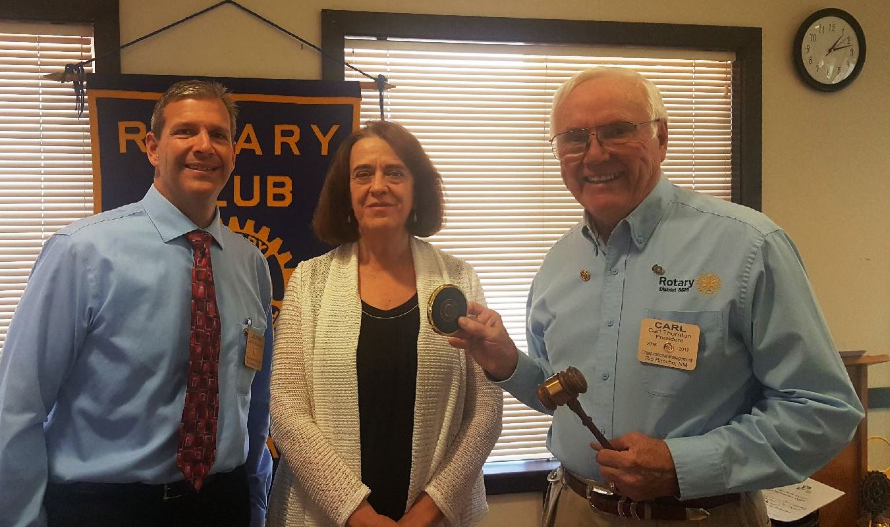
Left to right: Jerry Reeder, Dr. Sue Cleveland, Carl Thornton

THOUGHT FOR THE DAY: "Life is like an ocean; sometimes calm and sometimes stormy but still It has beauty."

