Rio Rancho Club of New Mexico
“HAPPENINGS” May 9, 2017
Darryl Gregreson, President of the Foundation Board, presented a check and recognition to the three Cleveland High School students that won the scholarship. They are Jacob Berry, Nikki Grewal, and Ceclia Torres. Their sponsor Katherine Hick-Lujan accompanied them.

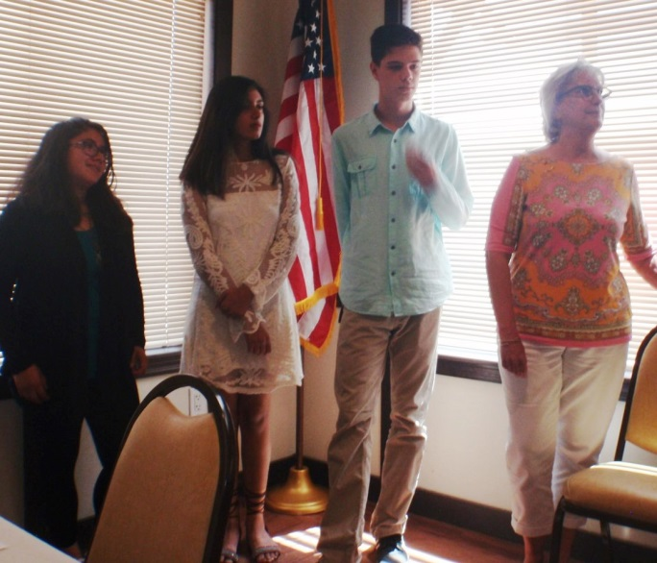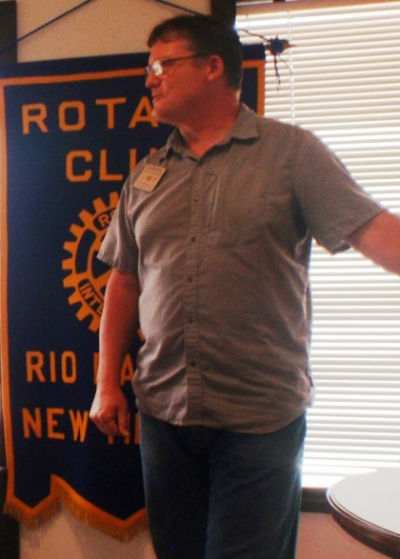

The program was excellent and very close to our hearts and hopes for New Mexico. Many thanks to Pauline Eisenstadt for arrange for this excellent presentation by Dayon Ely.

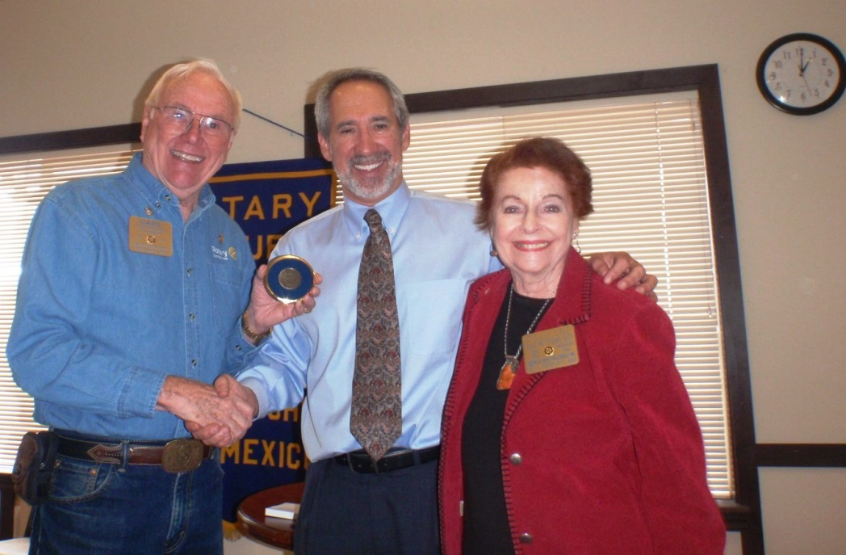

THOUGHT FOR THE DAY: Poor planning on your part does NOT cause panic on my part.

