Rio Rancho Club of New Mexico
“HAPPENINGS” February 14, 2017

Rotary of the Day Michelle Frechette arranged for a perfect Valentine’s Day program. Troy Lapsys, Joliesse Chocolates owner and chocolatier gave a most interesting program on the history, evolution, and demand for this wonderful product. Troy have out samples of the various types of Chocolate to all members. Yes, some of his chocolates were available to us that had not obtained a Valentine gift for our special Valentine spouses.
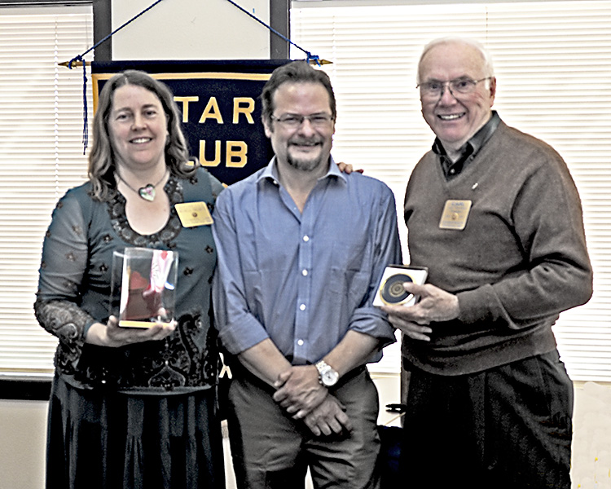

Photo by Walt Smith
President Carl Thornton presents a token our appreciation to Troy Lapsys for his special and timely presentation.

THOUGHT FOR THE DAY: The nicest thing about the future is that it always starts tomorrow.

