Rio Rancho Club of New Mexico
“HAPPENINGS” December 6, 2016

Beth will be our Rotarian of the Day for the December 20th meeting. She has a wonderful and interesting program for us to enjoy and to end 2016 on a happy moment.

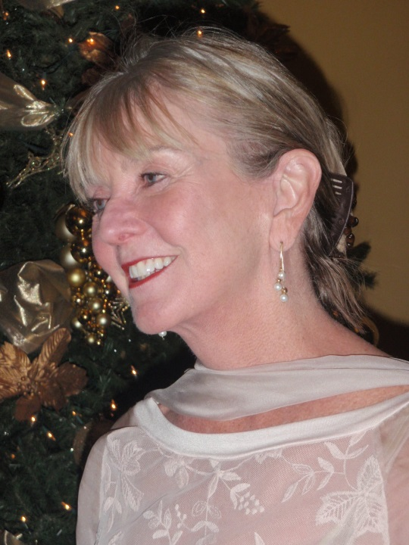
Sloan planned our 2016 Holiday Party that was enjoyed by all. She arranged for Frank to bring in a special band for our entertainment.

